 Volunteer Opportunity

Volunteer Opportunity Title
Volunteer Breeding Bird Surveyor
Reserve, Project, Team or Area
Mid-Swale Area (3 locations) North Team
Volunteer Manager
Claire Burton – River Restoration Officer
Why do we need you?
Are you a keen birder who could put their skills to use and contribute to Yorkshire Wildlife Trust monitoring? Do you love early mornings, gorgeous sunrises, and exceptional wildlife sightings? If you love birds, getting out into nature and exploring, then you will be perfect for the Volunteer Breeding Bird surveying (BBS) opportunity!

We are currently looking to recruit Volunteer Breeding Bird Surveyors across 3 private sites in the Mid-Swale area, these include:

- Pepper Arden Bottoms, Pepper Arden
- Southwood Farm, Danby Wiske
- The Batts, Colburn
Breeding Bird Surveyors monitor the status and trends of bird populations. The data collected helps us create maps of bird populations and helps us to understand where future works can be focused.
We are currently working on projects in the Mid-Swale area helping to improve connectivity for wildlife especially focusing on wetland creation and restoration. Data collected can give us a baseline indication of bird species present in the area which may lead to further habitat creation, or changes in management practice that will hopefully benefit that species.

If you are able to identify birds by call, song and by sight throughout spring and summer, we would love to hear from you. This is a great way to learn new skills, get some exercise and fill your lungs with fresh air.
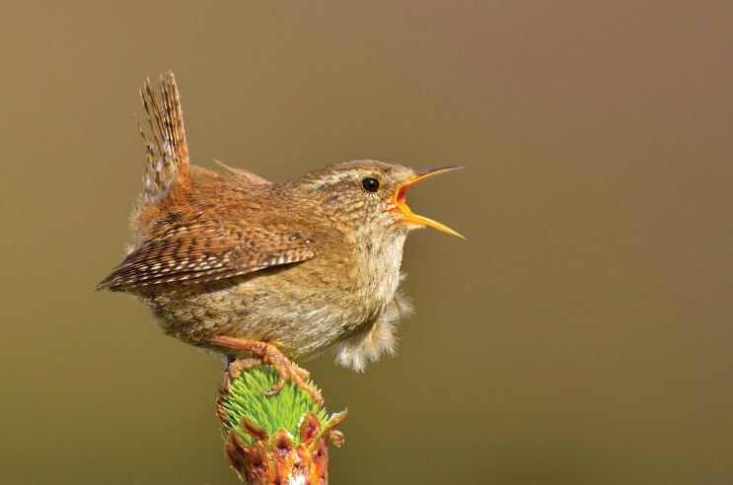
(Credit: Amy Lewis 2020Vision)

What will you be doing?
You will be assisting with Breeding Bird Surveys on one of three private sites to give baseline records of bird species present, and this will help us to focus future works in the area. You will do this by being involved with the following tasks:

- This volunteer role involves visiting the sites on your own. Full risk assessments and lone volunteering procedures will be shared as part of your induction.

- Undertaking bird surveys, usually 6 visits between April and July. Each survey will take around 2 hours on average, depending on the size of the site and the number of birds you hear.

- Mapping the behaviours, songs and calls you hear and see using the BTO (British Trust for Ornithology) codes provided.

- Reporting results back to the River Restoration Officer.

Experience, knowledge and skills needed for this opportunity
- Some Bird ID skills (both by sight and call), though there is also scope for people to team up with a more experienced birder and learn on the go.

- Must be reliable and a good timekeeper.

- Must be able to carry out each survey at the same time for every visit – the survey needs to be started by 9am at the latest, in order to be finished by noon. If you wish to start earlier than this that’s fine, as long as you can start by this time for all your visits.

Does the volunteer need a driver’s licence?
A driving licence would be ideal as some of the sites are in remote locations, however this is not needed if you live locally and can travel there by walking or by cycling.

What’s in it for you? (e.g. training, skills gained, social motivations)
- Be part of something- You’ll be involved in gathering important breeding bird records, which will allow us to gain an insight to the birds using the area.

- Learning and Development Opportunities- As a Yorkshire Wildlife Trust volunteer you will have access to a whole host of free volunteer training and opportunities which you are able to attend, as well as brushing up on your bird ID skills!

- Meet new people- We run an annual get together of volunteers, which you will be invited to attend.

- Get outside- Get to know new places throughout the Spring/Summer seasons. Best of all the surveys can only be done in good weather, so no rain or wind.

- Exercise- you’ll be walking a fair bit with this role and where better than out in nature!

Where is the opportunity based?
- Pepper Arden Bottoms, Pepper Arden
- Southwood Farm, Danby Wiske
- The Batts, Colburn

The River Restoration Officer for the Mid-Swale will join you for initial site visits to familiarise you with the exact location and explain what the role involves.

Commitment
Up to 6 surveys annually.
Duration
April to July on an annual basis.

If you’d like to apply for this volunteer role, please send in a completed volunteer application form to Volunteering@ywt.org.uk

