PART A: Which site are you risk assessing?
Assessor: Carl Lewis | Job title / role: Humber Operations Manager | Line managers signature (only to be completed if RA has been checked):
Date of assessment: 04/02/2025 | Date for revision: 04/02/2026 | Other related assessments – give filename/s (eg. site or task): n/a
Site/s or Location: Spurn | Map of site – give filename/location:  - See Appendix 1 | Facilities/welfare on site (eg. toilets):  - Toilets accessible to public: Spurn Discovery Centre (9am – 5pm)  - Toilets accessible to visitor groups: The Point (accessible during tours only)  - Café accessible to visitors: Spurn Discovery Centre (10am – 4pm)  - Staff toilet and welfare facilities: Bluebell Spurn Field Station and Warren
 |  | Local Authority area: East Riding of Yorkshire
 |  | RA Reference Number: SRA 2718
For Invasive Species risk assessment section see page 3.
PART B: In an emergency
Use this section to plan what you would do in the case of an accident or emergency incident on this site
Communications in the event of an emergency | Location of nearest landline/s:  - Spurn Discovery Centre: 01964 650 144  - Warren: 01964 207 144  - Lighthouse: 01964 650792  Location of strongest mobile signal (eg. entrance, top of hill):  - Areas of the site facing the south bank of the Humber  Which network?:  - EE  What are the alternative means of communication if necessary ?:  - Site two way radios (radios kept in Bluebell Spurn Field Station and Spurn Discovery Centre)  Details of Emergency contacts (other than 112/999):  - MOD Police: 01964 650692  - Northern Powergrid: 105
Emergency Access locations/terrain etc.  http://What3words.com  http://gridreferencefinder.com | Nearest postcode:  - Bluebell Spurn Field Station & Bluebell Flat: HU12 0UB  - Spurn Discovery Centre & Warren: HU12 0UH  - Lighthouse & Point Toilets: HU12 0UG  What3words for site:  - Bluebell Spurn Field Station & Bluebell Flat: skid.attend.hype  - Spurn Discovery Centre: prawn.tracking.theory  - Warren: lousy.ferrets.draining  - Lighthouse: excellent.acrobats.claw  - Lighthouse garages: workloads.jokers.converged  - Point Toilets: nature.grasp.patch  Road access points (What3words, OS Grid refs, and detailed description for each access point:  - Bluebell Spurn Field Station & Bluebell Flat: Accessible from Easington Road at listening.splat.punk/ TA41602 15854  - Spurn Discovery Centre: Accessible from Spurn Road at waxing.mango.pulse/ TA41681 15408  - Warren: Use padlock code ‘2270’ to pass gate at end of Spurn Road. Emergency parking is available outside the Warren building at sleepless.ambitions.sprouted/ TA41910 14988  4 x 4 vehicle access points (What3words, OS Grid refs, and detailed description for each access point):  - Access to the lighthouse and the point is only available by crossing the 1km wash-over area beyond the Warren. Review tide times and undertake assessment before proceeding in 4x4 vehicles, consulting Coastguard where necessary. The wash-over area starts at broached.martini.breed/ TA41952 14933 and finishes at maps.contracting.whisker/ TA42115 13698. Beyond the wash-over area, the road continues as partially tarmacked track.  Helicopter landing site/s (What3words, OS grid refs and detailed description of location & terrain):  - Warren: flat sand/ grass area 30m south west of Warren building: sleepless.ambitions.sprouted/ TA41907 14991  - Lighthouse: broken brick hard standing (former car park) 200m south of lighthouse: unhelpful.mute.dinner/ TA40177 11100
Nearest A&E/Minor Injuries Unit details | A&E  Hospital: Hull Royal Infirmary  Address (inc Postcode): Hull Royal Infirmary, Anlaby Road, Hull, HU3 2JZ What3words: belts.branch.affair  Minor Injuries  Hospital: Hull Royal Infirmary  Address (inc Postcode): Hull Royal Infirmary, Anlaby Road, Hull, HU3 2JZ What3words: belts.branch.affair  A map showing directions to both A&E and MIU are attached at Appendix 2

First aid | What is the minimum level of first aider qualification required?:  - First Aid at Work (L3)  Name of first aider/s or location of notices (for permanently manned sites):  - Notice of first aiders displayed in Bluebell Spurn Field Station and in Spurn Discovery Centre  Fixed first aid kit location/s, notices to this effect and kit type/contents required:  - Bluebell Spurn Field Station  - Spurn Discovery Centre  - Warren  - Lighthouse  AEDs also located at Spurn Discovery Centre and at Lighthouse garage
Accident reporting | Location of accident book/s & Incident Report Forms:  - Bluebell Spurn Field Station  - Spurn Discovery Centre  - Warren  - Lighthouse

PART C: Assessing the Risks

C1 – Spurn National Nature Reserve
Assess each risk below:-
Hazards/hazardous events (State the OBJECT that may cause harm, and how it may harm someone (eg’s Uneven path – trip, Giant Hogweed – contact with skin) | Who is affected and how many people?  (staff, contractor, volunteer, public, vulnerable group/s) | Typical outcome  State: Likely type/s of injury, fatality, or other outcome | How will the risk be controlled?  Completed by whom, when and how often?  How will the control measure be communicated?  (see Code of Practice 8 for advice on PPE) | Remaining Risk Level  Likelihood / Severity matrix  eg. likely x harmful = moderate
Vehicles being driven by YWT Staff:  - Vehicle collision with pedestrians/ other vehicles/ structures/ obstacles  - Vehicle rollover  - Vehicle becoming stranded on the washover | Vehicle drivers, vehicle passengers and other site users | Severe  Serious injury, drowning, death | - YWT vehicles cannot be driven on the reserve unless the driver has completed both a site induction and any applicable training that is required for the type of YWT vehicle that is to be driven  - Site signage at the reserve entrance warns reserve visitors/ users to be alert to vehicles and to keep out of vehicle tracks  - A speed limit of 20mph is in place across the reserve  - Following storm events and exceptionally high tides, the beach is to be inspected to ensure that both the north and south washover ramps are in a suitable condition before being used by drivers  - Vehicles are fitted with clinometers so that drivers can observe the angle of the vehicle as it is being driven  - Vehicle crossings of the washover are prohibited 90mins either side of high tide. This restriction can only be waived in an emergency and only in the event that the tide height at the time of driving allows the driver to navigate a safe path over the sand above the tide line  - Spurn has a three-step plan in place for vehicles that become stranded on the washover:  Step 1: All vehicles are equipped with sand ladder boards and a vehicle kit bag that provides the driver with self-rescue options in the event of a loss of traction/ a tyre issue that causes the vehicle to become stranded on the washover. The driver will assess the situation and instruct passengers accordingly, obtaining support from other YWT staff as appropriate using the two way radio  Step 2: In the event that self-rescue is unsuccessful, the driver will instruct passengers accordingly, obtaining support from other YWT staff as appropriate using the two way radio. The driver will seek tractor recovery, either via other YWT staff or by using the contact details provided within the information contained within the Vehicle Folder  Step 3: In the event that tractor recovery is unsuccessful, the driver will follow the procedure for a stranded vehicle as outlined in the Spurn Emergency Plan | Unlikely x Very Harmful = Moderate
Slips, trips and falls – uneven ground, steep embankments, ditches etc including:  - Uneven vehicle access ramp at southern end of washover  - Diversionary vehicle access route around collapsed road to south of washover ramp is an uneven sand dune surface  Speed bumps along concrete part of vehicle access route to The Point | All those on site | Severe  Sprains, broken bones, grazes. | - Suitable footwear to be worn (boots, good grips).  - Inspect and review vehicle and pedestrian routes following severe tidal/ weather events  - Undertake brush cutting to maintain clear pedestrian paths around the reserve  - Drivers to visually assess routes before driving  - Review routes if buried services become visible | Likely x Harmful = Moderate
Slips, trips and falls – fences and walls | All those on site | Slight  Cuts, twisted ankles | - Route pedestrian paths at a safe distance from walls and ensure that fences crossing paths have an appropriate gate to eliminate the need for climbing  - Task risk assessments must include measures to avoid climbing fences/ walls that are higher than chest height | Unlikely x Slight Harm = Trivial
Slips, trips and falls – Site concrete and historic remains including:  - Road slabs at post 37 have collapsed  - Seaward side concrete blocks around post 34/35 have large voids between block  - Desire line forming at tank ditch  - Undermining of wall at point south of jetty  - Falls from former historic military concrete infrastructure | All those on site | Severe  Sprains, broken bones, grazes, puncture injuries, entrapment in voids | - Suitable footwear to be worn (boots, good grips)  - Inspect and review coastal concrete following high tides and storm conditions (including for stability and cavities at poles 34-44)  - Monitor washover area and, where required, use grinding equipment to remove protruding metal from newly exposed concrete that could impact vehicle and pedestrian routes  - Monitor pedestrian paths for newly exposed concrete/ historic remains  - Display appropriate hazard warning signage at reserve entrance and at relevant locations where site concrete and historic remains represents a hazard  - Use rope barriers to prevent desire lines from developing away from the designated pedestrian paths  - Secure entry to excavated historic military tunnel on The Point to prevent unauthorised access | Likely x Harmful = Moderate
Falling trees, branches/ limbs and falling timbers or structures | All those on site | Severe  Broken bones, concussion, crushing | - Carry out annual tree condition survey and undertake remedial action as required  - Carry out annual hide condition survey and undertake remedial action as required  - Ensure pedestrian pathways are routed away from the point Heligoland Trap within which timbers have collapsed | Unlikely x Very Harmful = Moderate
Falling in sea/ beach washover and falling in other water bodies (e.g. scrapes) | All those on site | Severe  Drowning, hypothermia, shock | - Signage is displayed at reserve entrance and at either side of the washover area warning of the dangers of high tide  - High tide information is posted on the reserve website to advise on safe crossing times  - Provision of high tide shelter at south side of washover to encourage people not heeding notices to wait in safety for tide level to drop before returning across the washover  - No lone working in/near water  - Task risk assessments for activities in/ near water will reflect the measures outlined above and will factor in additional controls as necessary  - Pedestrian paths are to be routed at a safe distance from other bodies of water on site, such as scrapes | Unlikely x Very Harmful = Moderate
Roads and traffic | All those on site | Severe  Broken bones, crushing, death | - Gated access at the end of the public highway prevents non-authorised vehicles from accessing the reserve  - Undertake periodic flailing to the verges along the vehicle route to the south of the washover to provide sufficient space for pedestrians to safely step out of the road when vehicles are approaching  - Persons undertaking work in the car park/ in areas bordering the public highway are to wear high vis jackets | Unlikely x Very Harmful = Moderate
Utilities, including underground water pipes and overhead electricity wires | All those on site | Severe  Burns, electrocution, death | - Monitor dune heights under overhead electricity wires and advise Northern Powergrid of any changes (particularly around pylons 71-79)  - Check for utilities before digging, erecting posts etc. using the specific procedures outlined in the relevant task risk assessment | Unlikely x Very Harmful = Moderate
Fire on site, management fire out of control, arson etc | All those on site | Severe  Destruction of property (hides, buildings), burns, destruction of habitat | - ‘No BBQs/ fires’ signage is displayed at the entrance to the reserve  - Where fires are required as part of conservation work activity, task risk assessments must be followed  - Fire risk assessments and a log of tests/ checks of fire alarms and fire equipment are in place for the following buildings:  - Bluebell Spurn Field Station & Bluebell Flat  - Spurn Discovery Centre  - Warren  - Lighthouse | Unlikely x Very Harmful = Moderate
Weils disease / leptospirosis from contaminated water | All those on site | Moderate  Illness (flu-like), in rare cases death | - Route pedestrian paths at a safe distance from water that may be contaminated with mammal urine  - Task risk assessments involving work in or around water that may be contaminated with mammal urine must include measures to prevent water from coming into contact with skin whilst undertaking the activity and must contain the requirement to wash hands upon completion | Unlikely x Harmful = Slight
Lyme disease from tick bite and brown tailed moth | All those on site | Severe  Rash, swelling, lethargy, headache, allergic reaction | - Signage displayed at reserve entrance and across site warning of the dangers associated with ticks and brown tailed moths and where to seek further advice  - Task risk assessments must include measures to protect against ticks and brown tailed moths, including the wearing of long sleeves and trousers and the need to self-check for ticks after completing the relevant activity  - First aid kits on site contain tick removal tool to ensure ticks can be removed in a safe manner | Likely x Harmful = Moderate
Other biological risks including:  - Scratches and cuts from vegetation  - Toxic or irritant plants, such as ragwort and hemlock  - Contact with animal faeces (eg livestock or deer) | All those on site | Moderate  Rash, swelling, disease, allergic reaction, photosensitivity, cuts and scratches | - Brush cutting undertaken along pedestrian paths to keep vegetation height low to minimise likelihood of scratches and cuts  - Task risk assessments must include measures to protect against biological risks, including the use of PPR that is relevant to the activity being undertaken and the requirement to wash hands upon completion | Unlikely x Harmful = Slight
Contact with livestock (cattle and sheep) | All those on site | Moderate  Crushing, bruising, cuts, bites, fever/ illness from zoonoses | - Pedestrian paths are routed away from areas of the reserve that are being grazed with cattle  - Use of no-fence collars on cattle provides for the dynamic management of cattle to avoid contact with people on the reserve  - Regular inspection of livestock takes place to detect signs of disease  - Isolation and treatment of diseased livestock within areas that are secure from public access  - Signage is used to warn people not to approach livestock  - Task risk assessments must include measures to protect against contact with livestock, including suitable methods for rounding-up and safely restraining animals for welfare activities | Unlikely x Harmful = Slight
Conflict with other site users (including illegal site users) | Staff and volunteers | Slight  Aggressive behaviour, possibly leading to bruising, cuts etc | - YWT staff and volunteers are not to engage with threatening or intimidating behaviour exhibited by site users  - Lone worker policy requires regular radio/ phone check-ins with staff and volunteers so that potential conflict situations can be identified before they occur and to allow for appropriate assistance/ extraction to be arranged | Unlikely x Slight Harm = Trivial
Flotsum and jetsam | All those on site | Severe  Cuts, burns, poisoning, | - Signage displayed at reserve entrance and across site warning of the potential for ordinance to be present and instructions on what to do if a suspect item is found  - Task risk assessments must include measures to protect against flotsam and jetsam, including the need to visually evaluate suspect objects and containers with suspect contents prior to collecting | Unlikely x Very Harmful = Moderate
Flooding | All those on site | Severe  Isolation, falls, hypothermia, drowning. | - YWT is signed up to receive all flood warnings from the Environment Agency for the HU12 0UH location (Spurn Discovery Centre)  - YWT staff use the additional information on sea conditions available on the Surfline website to provide further context to the impact and consequences associated with a floor warning so that the necessary preparation/ evacuation action can be undertaken | Unlikely x Very Harmful = Moderate

C2 – Lighthouse
Assess each risk below:-
Hazards/hazardous events (State the OBJECT that may cause harm, and how it may harm someone (eg’s Uneven path – trip, Giant Hogweed – contact with skin) | Who is affected and how many people?  (staff, contractor, volunteer, public, vulnerable group/s) | Typical outcome  State: Likely type/s of injury, fatality, or other outcome | How will the risk be controlled?  Completed by whom, when and how often?  How will the control measure be communicated?  (see Code of Practice 8 for advice on PPE) | Remaining Risk Level  Likelihood / Severity matrix  eg. likely x harmful = moderate
Slips, trips and falls – lighthouse staircase | All those on site | Severe  Head injury, sprains, broken bones, cuts, bruises | - Safety briefing given by volunteers/ YWT staff to visitors prior to ascending from the ground floor (walk at all times, hold onto handrail, do not lean over the railings, stay in the middle of the staircase, keep control of younger visitors, no flip-flops/ high heels, no babies, no luggage etc.)  - Numbers are restricted so that no more than 30 visitors are allowed above ground floor at any one time  - Visitors who are unable to ascend and descend stairs un-aided are not permitted to proceed beyond the ground floor  - Regular inspection and cleaning of staircase by volunteers throughout the day  - Adequate lighting is provided for length of staircase to ensure steps can be seen clearly | Likely x Harmful = Moderate
Falls - through ballustrades on staircase | Smaller children | Severe  Death, head injury, broken bones, cuts, bruises | - A strong decorative plastic banner is securely attached to ballustrades on the open side of the staircase to provide a solid barrier that will prevent falls | Unlikely x very harmful = Moderate
Falls - steep ladder-style stairs to the lantern room | All those on site | Severe  Head injury, sprains, broken bones, cuts, bruises | - Signage advising on safe ascent/ descent methods is displayed at the foot and head of the ladder-style stairs to reinforce messaging provided during the ground floor safety briefing | Unlikely x Very Harmful = Moderate
Falls - platform surrounding the lantern room | All those on site | Severe  Head injury, sprains, broken bones, cuts, bruises | - Only 8 persons are allowed on the platform at any one time (enforced during busy times)  - Plastic barrier installed to prevent visitors falling through railings and down the staircase | Unlikely x Very Harmful = Moderate
Falls – opening windows | All those on site | Severe  Death, severe injury | - Locking screws are fitted to all windows to prevent opening | Unlikely x Very Harmful = Moderate
Falls - exterior platform at the lantern room | All those on site | Severe  Death, severe injury | - Access to the external platform is prohibited to all except specialist maintenance contractors who possess, and are competent in the use of, the safety equipment specified in their Risk Assessment/ Method Statement for the work being undertaken  - The handle required to operate the opening mechanism on the hatch leading out to the exterior platform is securely kept in the service cupboard on the ground floor of the lighthouse to prevent unauthorised opening of the hatch by unauthorised persons | Unlikely x Very Harmful = Moderate
Fingers/ hands becoming trapped between stair handrail and wall | All those on site | Moderate  Bruising, cuts, sprains | - Soft barrier materials have been affixed where traps may occur | Unlikely x Harmful = Slight
Fingers/ hands becoming trapped within air vents in lantern room | All those on site | Moderate  Bruising, cuts, sprains | - Rear nuts on vent panels to be tightened to lock vents in the open position | Unlikely x Harmful = Slight
Fingers/ hands becoming trapped in central pillar doors on ground, third and fourth floors | All those on site | Moderate  Bruising, cuts, sprains | - The doors are secured with a nut and bolt to prevent them from being opened | Unlikely x Harmful = Slight
Low ceilings/ protruding girders on staircase | Adults or tall children | Moderate  Head injury, cuts, bruises | - Soft barrier materials are affixed on locations where head bumps are likely  - Warning signs are in place to alert those using the staircase of the upcoming hazard | Unlikely x Harmful = Slight
Walking into glass doors/ large windows | All those on site | Moderate  Bruising, cuts, sprains | - Stickers are affixed on glass doors and windows to ensure that transparent surfaces are visible | Unlikely x Harmful = Slight
Falling objects (objects dropping through open staircases etc.) | All those on site | Moderate  Bruising, cuts, sprains | - Visitors are monitored on CCTV system to ensure that they are adhering to the safety briefing provided at the ground floor | Unlikely x Harmful = Slight
Climbing on sloped surfaces in first and second floor low light rooms | All those on site | Slight  Bruising, grazes | - No climb notices are displayed on the sloped surfaces  - Interpretation is placed to prevent access onto the sloped surfaces | Unlikely x Slight Harm = Trivial
Contact with mains electricity | All those on site | Severe  Death, burns, electrocution | - Accessible plugs that are not in use are fitted with child socket protectors  - Only appliances that are new or that have been PAT tested are to be used in the lighthouse | Unlikely x Very Harmful = Moderate
Fire | All those on site | Severe l  Death, burns, suffocation, severe injury | A fire risk assessment and a log of tests/ checks of fire alarms and fire equipment are contained in the Lighthouse Fire Log Book | Unlikely x Very Harmful = Moderate

Map of site
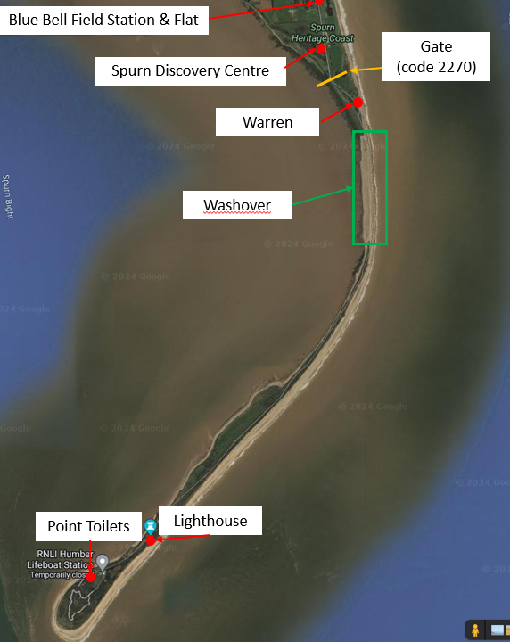

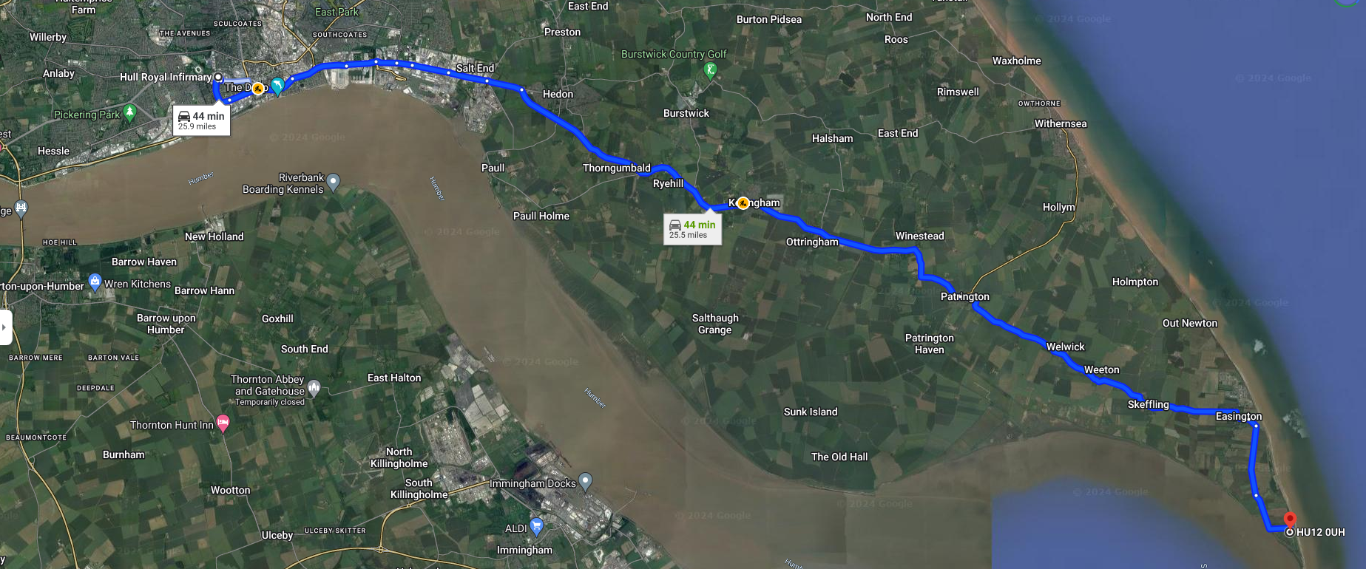
Map showing directions to Hull Royal Infirmary A&E and MIU from Spurn National Nature Reserve:

