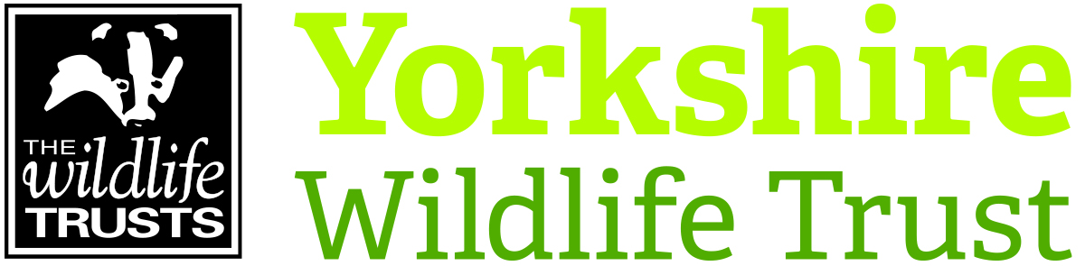 Volunteer Role Description

Volunteer Role Title
Puffin Festival Volunteer
Reserve, Project, Team or Area
Events and Engagement
Volunteer Manager/Supervisor
Joy Kemp, Visitor Engagement Team
Why do we need you?
We’re looking for a team of enthusiastic volunteers to help us welcome visitors to our annual Yorkshire Puffin Festival! We need your support to further inspire members of the public about this charismatic species and the abundance of wildlife that can be experienced along the Flamborough headland.

The festival will take place from 7th and 8th June 2025 and the packed programme will include guided walks, boat trips, intriguing engagement activities at Puffin HQ and of course appearances from our very own Cliff the Puffin!

Last year we welcomed around 3000 people to the festival who travelled from far and wide and the atmosphere is buzzing! We need your help to make sure that everyone who spends the day with us has the best possible experience…

As well as meeting lots of fantastic people, you will be volunteering at the stunning location of Flamborough North Landing
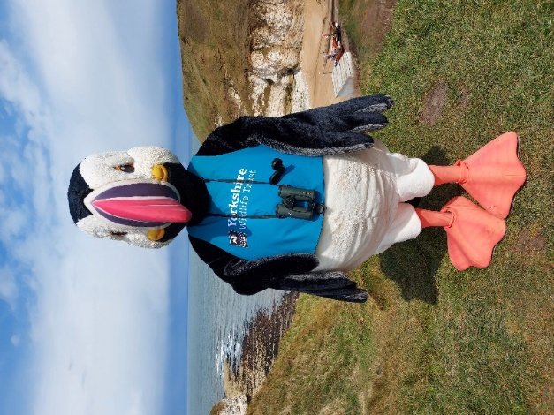

Cliff the Puffin needs your help to put on the 2025 Puffin Festival!

What will you be doing?
As part of the event, we will have our ‘Puffin HQ’ at North Landing in Flamborough. Yorkshire Wildlife Trust, where gazebos will provide a base for the information point, alongside stands with a variety of activities going on (to be confirmed)

We would like Puffin Festival volunteers to:

- Help with set up and pack down
- Assist with welcoming visitors at Puffin HQ and relaying information about the festival events and activities
- Assist with running engagement activities
- Back marking guided walks

This is a public facing role offering outdoor volunteering with lots of opportunities to engage with visitors about a fantastic subject and a much-treasured species.

Please note that the gazebo will be located outdoors.

Car parking, catering and toilet facilities will be located nearby.

What’s in it for you?
- A chance to inspire others about the natural world
- Development of communication skills
- Development of engagement skills
- Access to our free in-house Volunteer training programme
- Be part of a fun and inspiring team of YWT staff and volunteers
- A chance to learn more about the amazing Yorkshire coast and the wildlife that calls it home.
- We can make a contribution towards reasonable travel expenses.
Where is the role based?
North Landing, Flamborough, East Yorkshire
Commitment
The ‘Puffin Information Point’ will be open during the following times:

- Sat 7th June: (Set up from 8am) Festival open from 10am – 4pm
- (Morning slot: 8am – 1pm; Afternoon slot: 12:30pm – 4:30pm)

- Sun 8th June: (Set up from 8am) Festival open from 10am – 4pm
- (Morning slot: 8am – 1pm; Afternoon slot: 12:30pm – 4:30pm)

We’re flexible on how the rota for the stand can work based on your availability but initially suggest morning and/or afternoon sessions that are four hours long. If you can do a morning or afternoon, or both days, we would love to hear from you!
Duration
Daytimes – Saturday 7th June and Sunday 8th June.

