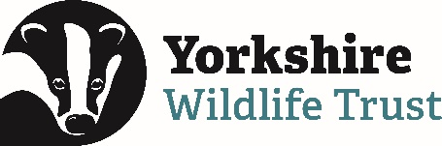 Volunteer Opportunity

Volunteer Role Title
Volunteer Livestock Checker – Low Carr Farm
Reserve, Project, Team or Area
North Team, Conservation Grazing Project based at Low Carr Farm, near Pickering North Yorkshire

Volunteer Manager/Supervisor
Angus Lee – Conservation Grazing Manager
Why do we need this volunteer?
Yorkshire Wildlife Trust manages over 100 reserves, restoring biodiversity, protecting habitats and wildlife and providing wonderful opportunities for visitors to get close up and see some of our most enthralling wildlife. Part of the management of many of our grassland, fen and heathland reserves is carried out by grazing animals.

Grazing helps control competitive ‘rough’ plant species that can out-compete the finer, more interesting species of grass and wildflower that we seek to encourage. Livestock on the reserves need to be checked on three to four times a week to ensure that their health is good, and that they are still all there. Local volunteers who can visit the site each week will reduce the need for staff to travel to this site on a daily basis and ensure livestock are happy and well.

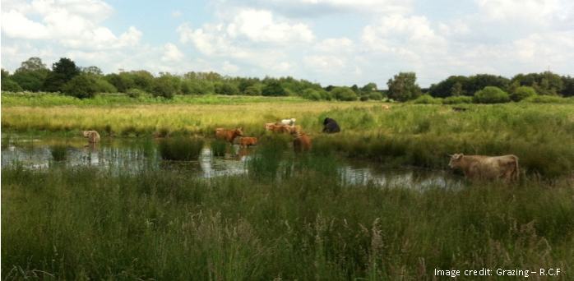

What will you be doing?
- Each visit involves a short to medium walk around the area being grazed, checking fence lines, counting the number of animals and looking for any signs of ill health. If you did see any problems, you would not be expected to deal with them, simply to ring your volunteer manager to let them know the scenario.
- We usually work a rota system, so a group of people take it in turns to check stock at a certain site, so each individual’s commitment is not too great. Roughly once a week or once a fortnight is normal. Once livestock have been checked volunteers are asked to send a brief message to their volunteer manager, letting them know all is well.
- An introduction to the site and livestock will be given, with a site and task risk assessment. Training on what to look out for, common problems encountered, tell-tale signs of illness etc. will be given in person and followed up by a reminder document.
- There will be other opportunities to learn about the livestock and help with routine animal welfare tasks if volunteers express a wish to do so.

Experience, knowledge and skills needed for this role
- No previous knowledge or experience necessary, but you need to feel confident being around grazing animals, and any past experience or knowledge of stock welcome.
- The main requirement is reliability – the volunteer must check the stock on their allocated day, or let us know if they can’t so we can make other arrangements.
- You also need to be fairly physically fit as some of the grazing areas have rough terrain, tussocks, boggy ground etc that you need to be able to negotiate.

Does the volunteer need a driver’s license? Ideally yes – unless you live within walking or cycling distance of the reserve.
What’s in it for you?
- The chance to spend quiet time on one of YWT’s superb reserves which is normally not accessible to the public; you will often spot fantastic wildlife close up while stock checking.
- The chance to get to work with our livestock and learn more about the amazing role cattle and sheep play in creating wildlife friendly habitats.
- Learn skills in animal welfare and management if desired.
- Learn some more about nature reserve management and meet other like – minded people.
- Access to our free volunteer training programme and volunteer events throughout the year.
- 15% discount in Yorkshire Wildlife Trust shops. 15% discount at Yorkshire Wildlife Trust cafes when you are volunteering.

Where is the role based?
Low Carr Farm, near Pickering North Yorkshire
Commitment
Monday, Wednesday or Friday. One day a week, each visit may take about an hour. You can commit to doing this as little or as often as you can manage - any help is appreciated. This role is available all year round.

Duration
Ongoing – we will always be wanting cattle and sheep to be grazing our reserve and the numbers fluctuate according to time of year and land availability.

