 Volunteer Opportunity

Volunteer Opportunity Title
Events & Engagement Volunteer – Marine
Reserve, Project, Team or Area
Visitor Engagement Team / Yorkshire Coast (Scarborough, Filey, Flamborough and Bridlington)

Volunteer Manager
Sophie Atkinson, Inspiring People Officer – Marine
Why do we need you?
Nature is amazing and we want your help to tell everyone! Yorkshire Wildlife Trust is creating a county rich in wildlife and we need enthusiastic, nature loving volunteers to help inspire people to have a lifelong connection with nature and wildlife.

We have a jam-packed seasonal events programme planned for this year, including rockpool safaris, fossil walks, crafting sessions and boat trips. In addition to the events programme, we also host education sessions with local schools and colleges.

We are looking for people who can bring bags of enthusiasm and fun to help us to deliver these events throughout the seasons to our many visitors and supporters.
What will you be doing?
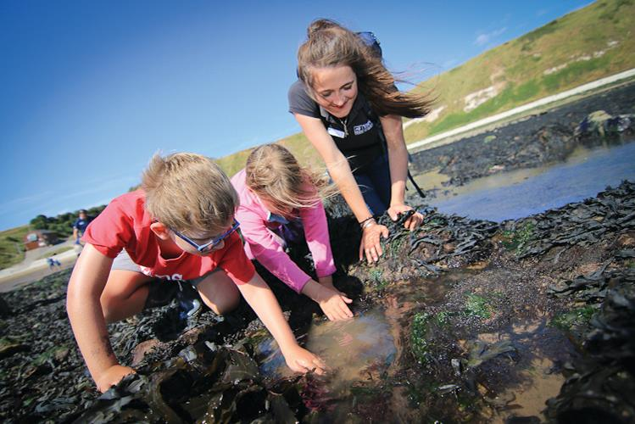
At the Living Seas Centre and along the Yorkshire Coast, we run a range of events across the year to inspire people of all ages about the marine environment. Staff and volunteers run a variety of events, from school and group visits to our Wild, Wilder and Wildest themed events for the public. As a volunteer in this role you will help to deliver these activities, representing Yorkshire Wildlife Trust, and share your passion for nature with others whilst providing a high-quality visitor experience.
Photo Credit: YWT

We’re looking for volunteers to:

- Assist the Inspiring People Officer in the smooth running of events and school/group sessions
- Assist in preparing of equipment, resources and materials
- Assist in room set up
- Greeting participants
- Help staff with managing groups to ensure everyone stays safe and has a great visit
- Engage with visitors and communicate key messages and the wider work of the Trust
- Assist in the packing away of materials and equipment
We can also offer:

- The option to independently deliver elements of events, such as drop-in craft activities, boat trip commentary and Peering at Puffins sessions
- Potential involvement of the promotion of our events – you could help with the leaflet and poster drops in your local area
- Potential key holding responsibilities.

Experience, knowledge and skills needed for this opportunity
The most important thing you will need is enthusiasm and a willingness to learn and share with others and we’d love you to have some of these too:

- An infectious passion for nature and being outdoors
- Willingness to have fun outdoors in all weathers
- Capable of working on your own and with others
- Ability to be reliable and punctual
- Ability to follow instructions and on occasion work with minimum supervision
- Great communication skills
- Good time keeping
- Ability to share knowledge clearly and inspire others
- Experience of working with children
- Knowledge of the natural environment and British wildlife (particularly marine)
- Awareness of safety outdoors
- First Aid certificate – not essential, but useful if you do have one.

A full induction and any necessary training that you identify with the volunteer manager will be given to all volunteers.

Does the volunteer need a driver’s licence?
No, but please be aware that travel to the Living Seas Centre and other areas of the Yorkshire Coast can be difficult on public transport.

What’s in it for you?
- A chance to learn more about the amazing Yorkshire coast and the wildlife that calls it home.
- A chance to inspire others about the natural world
- Development and use of leadership skills
- Development and use of communication skills
- Development and use of engagement skills
- Be part of a fun and inspiring team
- Access to a free Trust-wide volunteer training programme and onsite training opportunities.
- 15% discount in YWT shop
- Contribution towards travel expenses
- Uniform provided.

Where is the opportunity based?
Living Seas Centre (Flamborough) and along the Yorkshire Coast (Scarborough, Filey, Flamborough and Bridlington).

Commitment
Our events programme runs all the year round and you can volunteer as much as you are able to! We’d suggest at least once a month as this will help you stay connected with the team and what’s happening.

This volunteer role will mostly involve helping with public events and school/group sessions which take place Monday to Sunday, so we are looking for help on any of those days.
Volunteers are emailed a list of upcoming dates each month and they can then choose which dates to volunteer.
Duration
Ongoing – we have a programme of events and education session all year round, with the busiest period falling between April to September.
Is this opportunity accessible?
We encourage anyone with any access or support requirements to contact us to talk about how we could make any reasonable adjustments to this volunteering opportunity. This opportunity is physical and requires carrying equipment, walking over uneven ground, and walking up and down steep slopes to access the beach.

Internal Information Only- NOT TO BE PUBLISHED
Recruiting Information (standard: YWT website, Environment Jobs, CJS and Conservation Jobs)
How many volunteers are needed in this role/team? 6
Request Date:
Desired deadline date: Open ended recruitment
For example you could choose a 4 week deadline, please do not put ASAP as we have a high volume of recruitment to manage – thank you

Interview date (if applicable): N/A
Any particular requirements or suggestions (e.g. a volunteer centre, local publications): N/A

Does this volunteer role carry out tasks that other teams work on across the Trust?
(For example; communications, marketing, events, and outreach)
Events and outreach

Does this opportunity involve working with children or adults at risk? If necessary, the role may require a Disclosure barring and service check.
Yes. An enhanced disclosure is not needed for this volunteer role but it will be subject to reference checks as it involves volunteering with families and school groups.

If yes, will the volunteer have supervisory responsibility for the children or adults at risk? If so, how frequently? (give details e.g. once per week, per month): No

Will the opportunity involve any other sensitive tasks for which we may wish to check suitability via references? (e.g. confidential & sensitive data, financial information or cash handling)
No
Is this opportunity suitable for a young volunteer? Please indicate:
Yes, if parental consent is provided (age 16 and 17 years)
Yes, if supervised by a parent/guardian, who also registers as a volunteers (aged under 16 years old).

Will there be any other training for the volunteer to undertake?

Please identify what training your volunteer needs if leading practical activities or managing volunteers (or significant work alone or unsupervised):
- First Aid Preferable but not essential training
- Volunteer Management No
- Event Leader Yes, if interested in leading some events
- Task Day Leader No
- Safeguarding Yes

Does your volunteer require any of the online training modules?
For example, slips, trips and falls, ladder training, or desk based assessments.

Other Essential: No Other Desirable: No

What equipment is required to fulfil this role? (inc. computer software/licences, PPE)

Office: Desk: No Computer: No Software: N/A
Personal Protective Equipment: Sturdy, waterproof shoes (e.g. wellies) and outdoor clothing
Other: N/A

Have you identified the necessary budget to cover the training, PPE, equipment and travel expenses of this volunteer role? (give details)
Yes

Please refer to the generic Volunteer Induction Checklist and tailor to suit this role

