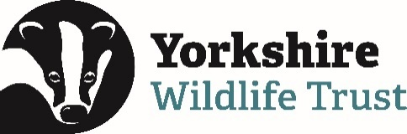 Volunteer Opportunity

Volunteer Opportunity Title
Volunteer Photographer
Reserve, Project, Team or Area
Yorkshire Wide
Volunteer Manager
Volunteering Support Officer
Why do we need you?
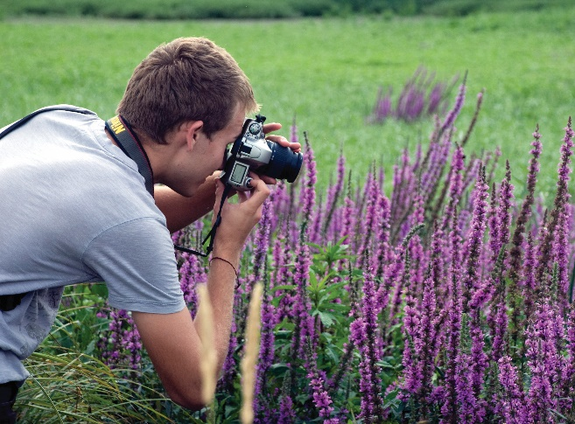

Nature is amazing and we want to tell everyone! Yorkshire Wildlife Trust is creating a county rich in wildlife and we need passionate volunteers to help people develop a connection with nature. We know that great photographs showcasing our amazing people and places really CAN paint a thousand words… and that’s why we need you!

Are you a keen photographer with a passion for the natural world? Do you love discovering new people and places and documenting them in pictures? Would you like to support Yorkshire Wildlife Trust by using your photography skills to help us build a stock of high quality images that we can use on our website, membership magazine and in our Volunteer publications?

We are looking for photographers who can take great images either of landscapes, people, or both! So whatever your specialism, we would love to hear from you. (Please note, though, that we have a good stock of wildlife images at the moment, so you wouldn’t be specifically required to take these… though of course you’d be welcome to for your own enjoyment!)

What will you be doing?
- Helping us to build up our stock of good quality images of our nature reserves across all four seasons of the year
- Visiting our reserves across Yorkshire to photograph our events and meet our visitors, volunteers and staff
- Going along to some of our conservation Task Days to get to know our amazing volunteers and capture their hard work on camera
- With the Volunteering and Comms team at YWT, agree a plan for attendance at events and reserves where we’ve identified we need good quality, up to date images (this can be flexible depending on your availability)
- Attend a variety of events which are open to the public, such as bat walks, forest schools and crafting sessions, gaining the consent of visitors to use any personal images

Knowledge and skills needed for this opportunity
- A genuine enthusiasm for photography
- An affinity with Yorkshire’s nature and wildlife
- The understanding of what makes a high-quality photograph, and the ability to put this into practice with your images
- You’ll be comfortable interacting with a wide range of people – adults and children, visitors from all backgrounds and YWT volunteers – to put them at their ease when you are photographing
- Willingness to travel to attend events and visit reserves (this can be flexible depending on your availability, however we are looking to cover as wide an area of Yorkshire as possible)
- The ability to access our reserves safely – you may encounter steep slopes, uneven ground and stiles for example, and sometimes you’ll be out in all types of Yorkshire weather!
- You should be comfortable with volunteering alone on occasion, and be willing to take sensible precautions to ensure your own safety, and to follow YWT guidance on lone working
- You’ll have access to camera equipment to enable you to take high quality images
- You should be comfortable with using cloud-based software to transfer image files to the Volunteering Support Team, or be willing to learn
- You’ll need an understanding of the importance of gaining consent for images of individuals, and a commitment to following YWT guidance on this at all times (we can support volunteers with this)

Does the volunteer need a driver’s licence?
Yes, you will need a full driving licence and use of a vehicle as many of our reserves are remote and difficult to reach by public transport.
What’s in it for you?
- You’ll get to visit a wide range of our beautiful reserves across Yorkshire, including many lesser-known gems
- Access to some amazing events including rock pooling, UniMog safaris at Spurn Point, fungi walks, food festivals and forest school sessions
- An opportunity to build and diversify your portfolio and use any images you take whilst volunteering for us for your own purposes
- Full credit whenever your photos are used in our membership or volunteering publications, or on our social media channels
- Invites to exclusive celebration events for YWT volunteers
- Access to our free in-house training programme
- 15% discount in Yorkshire Wildlife Trust shop and 15% discount at cafes when volunteering
- Support from a dedicated Volunteer Manager in the Volunteering Support Team

Where is the opportunity based?
Across Yorkshire, with flexibility depending on where you are based. Catch ups with your Volunteer Manager can be in person or over Teams, depending on what works best for you
Commitment (how often and when? e.g. every Wednesday or once a month)
Flexible- to be agreed with the volunteer
Duration
Long term

Is this opportunity accessible? Please provide as much detail as possible.
There is a requirement in this role to visit our reserves, some of which are remote and without level and safe access routes.

If you would like to discuss whether this role could be suitable for you please feel welcome to contact the Volunteering Team at volunteering@ywt.org.uk – we are happy to discuss any kind of accessibility need in relation to you volunteering with us.

