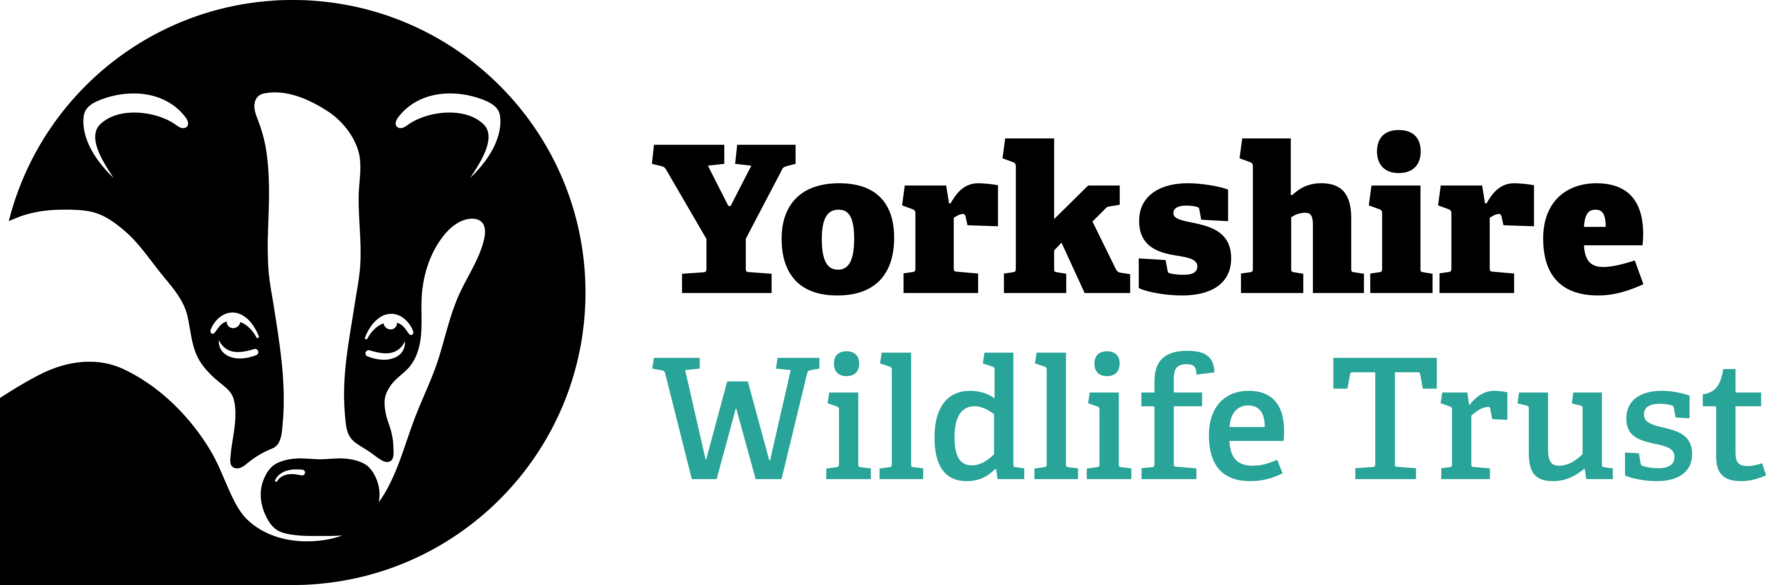

Voluntary Trainee Role Title

Northern Projects Voluntary Placement – Survey and Monitoring

Supervisor
Vanessa Barlow
Reserve/Project/Team/Area
North Project Team - based at York with a suite of projects across North and West Yorkshire
Background
Yorkshire Wildlife Trust (YWT)’s mission is to create a Yorkshire rich in wildlife for the benefit of everyone – more wildlife, more wild places and more people having a strong connection to nature. Within our Northern region we manage 36 nature reserves, as well as a number of exciting projects. Enabling nature’s recovery takes time and effort and the North Team benefits from the help and support of volunteers to make our vision a reality, whilst providing a first-rate learning and development opportunity for people wanting to focus on a career in nature conservation.

The role of the Survey and Monitoring Voluntary Placement is for the volunteer to support and be involved in the management of conservation projects. Working alongside a team of knowledgeable staff, you will help in the planning, development, and the practical delivery of this work. This role will allow you to develop an in-depth understanding of working in the conservation sector -you will gain experience in developing species specific projects on a local scale whilst working alongside landowners on private land.

You will also have an opportunity to be directly involved in projects which help to increase the spread and distribution of our native species as part of nationally important partnership projects – specifically great crested newts and white clawed crayfish.

There will also be opportunity to gain experience in other monitoring projects (e.g. botanical, habitat, birds).

What will you be doing?
On this Voluntary Placement you will gain experience working on survey and monitoring projects across the county. You will be based in YWT’s York office with field work predominantly carried out across North and West Yorkshire. You will primarily assist our project officers in undertaking work on third party land, however there will also be the opportunity to work with other members of the team to enhance your development. You have the opportunity to gain experience in the following areas:

- Species survey and monitoring as part of national and local schemes including environmental DNA (eDNA) and traditional methods
- Riparian ecology, restoration and monitoring
- Land management techniques to improve water quality
- Wetland habitat creation
- Undertaking practical tasks such as habitat creation and restoration
- Gain familiarity with budgets and project management tools
- Mapping, administrative and GIS work using QGIS and Survey123
- Publicising project work via traditional communications, social media and engagement events
- Coordinating volunteers for survey work and events
- Engaging with farmers, landowners and other stakeholders

What’s in it for you?
- A full induction to the role
- Regular one-to-ones with your line manager
- Ongoing personal development, allowing you to develop nature conservation skills and valuable experience towards a career in this highly competitive sector
- External training to include habitat surveying, and a recognised great crested newt survey training course which would count, in part, towards obtaining a CL08 survey licence, OR a CIEEM accredited ‘Working with Crayfish’ course which would contribute towards obtaining a CL11 Licence (Please note, successfully obtaining either of the licences mentioned would be subject to additional self-directed survey experience outside the scope of this role)
- A programme of in-house training courses will be available throughout your traineeship
- Access to our free varied volunteer internal trainee training programme
- Branded uniform
- Reasonable travel expenses
- An intensive and high-quality experience that will stand out on any CV, as a team member of one of the UK’s most vibrant and varied conservation organisations

80% of volunteers on longer term placements with YWT have successfully found employment within the sector, or gone on to relevant further studies.

Experience, knowledge and skills needed for this role
You will need:
- Enthusiasm for wildlife and conservation
- A friendly and approachable nature
- Be reliable, motivated and able to use initiative
- Be able to work in a team and get along with a range of people
- The ability to communicate effectively and willingness to talk to groups
- Be computer literate in Word and Excel
- Have the ability to research, gather information and compile reports and plans
- Have good organisational and time keeping skills
- Experience of using GIS software, OR willingness to learn
- Happy to work from the office/in the field with occasional remote working

Does the Trainee need a driver’s licence? Yes - Most of our work sites are located in remote locations, away from main public transport routes, therefore this role is suited to a person who holds a full driving licence and is willing to drive as part of the role. There are a pool of YWT vehicles based at the York office which are shared amongst the teams and which you could have access to.

This role involves being outdoors in natural environments where there will be occasional risks from biohazards such as ticks, leptospirosis, insect bites and similar.

Tasks near or in shallow water are common, so applicants should ideally be able to swim.

Commitment
2 or 3 days per week, between Mon-Fri (there is some flexibility here but Tuesday to Thursday would be preferred).

This role will be a mix of office-based work but will include travel to sites & reserves across the county.
Duration
6-months (ideally starting April 2025)
To apply for this Voluntary Placement, please complete an Application Form and return it to volunteering@ywt.org.uk by the closing deadline: 28/02/2025

