 Volunteer Opportunity

Volunteer Opportunity Title
Stock Checker – Doncaster Reserves
Reserve, Project, Team or Area
Volunteers needed at Parson’s Carr, Potteric Carr, Denaby Ings, Carr Lodge
Volunteer Manager
Sophie Pinder (South Reserves Officer) / Katie Baker (South Reserves Assistant)
Why do we need you?
Parson’s Carr is our newest nature reserve in South Yorkshire, comprising grassland and wetland habitats which need management using grazing animals. Grazing helps control competitive ‘rough’ plant species that can out-compete the finer, more interesting species of grass and wildflower that we seek to encourage. Livestock on the reserves need to be checked every day, if possible, to ensure that their health is good, and that they are still all there. Volunteer help doing this will save much staff time, freeing us up to carry out other essential work to keep our reserves in good condition.

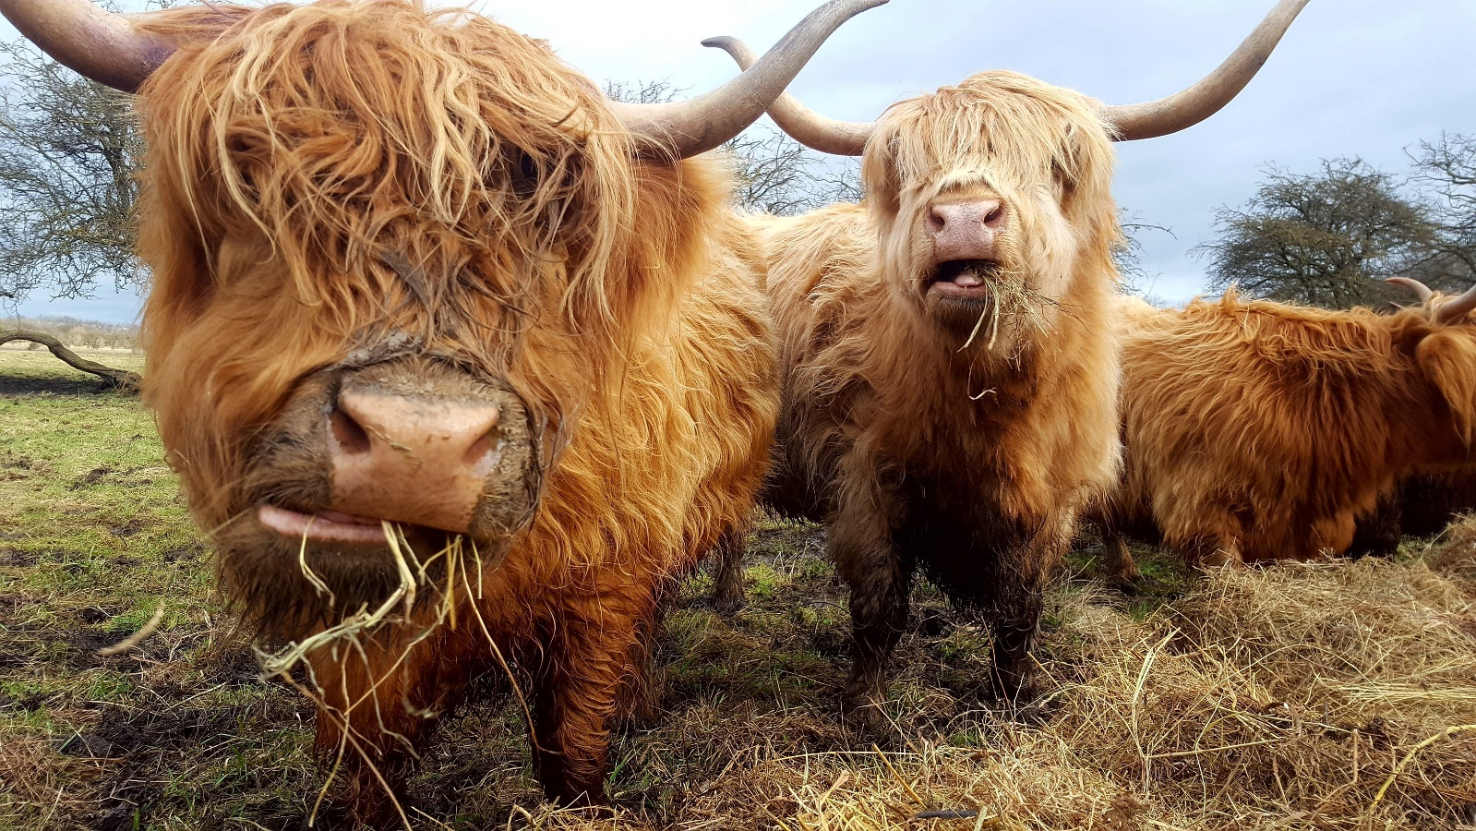

What will you be doing?
- Each visit involves a short to medium walk around the area being grazed: checking for damage to fences, ensuring the drinking water supply is ok, counting the number of animals and looking for any signs of ill health. If you did see any problems, you would not be expected to deal with them, simply to ring us at YWT to let us know.
- We usually work a rota system, so a group of people take it in turns to check stock at a certain site, so each individual’s commitment is not too great.
- An introduction to the site will be given, with a site and task risk assessment, plus information on what to look out for, more common problems encountered, telltale signs of illness etc. This will be given in person on site and/or followed up by a written reminder document.
Experience, knowledge and skills needed for this opportunity
- No previous knowledge or experience necessary, but you need to feel comfortable being around grazing animals, and any past experience or knowledge of stock welcome.
- The main requirement is reliability – the volunteer must check the stock on their allocated day, or let us know if they can’t so we can make other arrangements.
- You also need to be fairly physically fit as some of the grazing areas have rough terrain, tussocks, boggy ground etc that you need to be able to negotiate.

Does the volunteer need a driver’s licence?

Yes – unless the volunteer is reliably able to get to the reserve by other means
What’s in it for you?
- The chance to visit one of YWT’s superb reserves throughout a season, seeing it develop and change, and enjoying the wildlife it supports.
- The chance to get to work with our grazing stock. Each have their own personalities and are a joy to get to know.
- Learn skills in animal welfare and care.
- Learn some more about nature reserve management

Where is the opportunity based?
At any of the following reserves – Potteric Carr, Denaby Ings, Carr Lodge or Parson’s Carr
Commitment
Each checking visit may take between fifteen minutes and an hour, depending on where the stock are on the site. You can commit to doing this as little or as often as you can manage - any help is appreciated. Weekly or twice monthly visits are average.
Duration (how long will the role last? e.g. ongoing or every week from April-August)
The grazing period of the site (potentially all year-round)

