 Volunteer Opportunity

Volunteer Opportunity Title
Volunteer Butterfly Survey Co-ordinator
Reserve, Project, Team or Area
Data & Evidence Team, Nature Recovery Directorate - this role can be homebased if the Volunteer has access to the internet.
Volunteer Manager
Beth Clarkson, Evidence Officer
Why do we need you?
At the Yorkshire Wildlife Trust, we want to significantly enhance our impact for nature. Our ambitions are high, and we must do what we can to reverse the decline of wildlife in Yorkshire for the generations to come. Much of our work is delivered through our dedicated and skilled volunteers, who are some of our most knowledgeable people locally.

Each year, Yorkshire Wildlife Trust carries out transect surveys of butterflies on many of our nature reserves. The information is gathered by a team of volunteer surveyors and the results are used to inform our Reserve Management Plans. The collected data is also passed to the Butterfly Conservation Trust as part of their nationwide monitoring effort that takes place across the UK, also known as the United Kingdom Butterfly Monitoring Scheme (UKBMS).

We’re looking for an individual with good organisational skills, who’s great at communicating and has an eye for detail, who can coordinate our team of volunteer Butterfly Surveyors, deal with the associated admin of the project and liaise with The Butterfly Conservation Trust to deliver an event once a year (for more details on this, see below).

Would you like to use your existing project management skills to support our work, or learn how to manage a multi-layered project? Then we would love to hear from you! This is an exciting opportunity to coordinate a monitoring project that is making a real difference to Yorkshire’s wildlife and contributing to a national programme, and one that’s invaluable to the Trust.
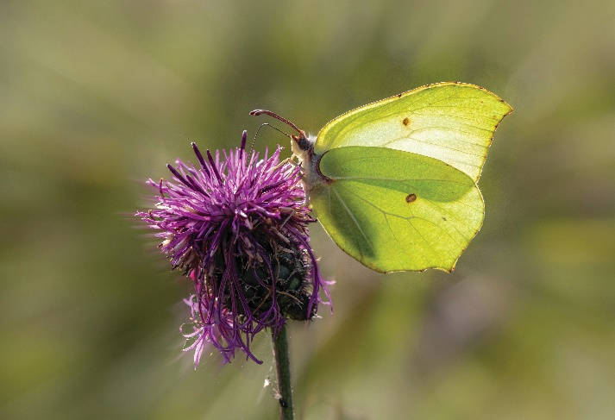

Photo Credit: Brimstone, Erik Karits
What will you be doing?
You will be working with our Evidence Officer and Volunteer Surveyors to ensure butterfly surveys are carried out each season. The main elements of the role will involve contacting new and existing surveyors to organise when and where they will be surveying in the coming season. In addition, we’d like you to help organise the annual get-together we hold, where volunteer surveyors can swap tales, highlights of the previous season and The Butterfly Conservation Trust can provide feedback following their analysis of our collective results.

Supported by our Evidence Officer, the key aspects of the role are as follows:
- Confirming new and existing volunteers for the upcoming survey season
- Creation of survey rotas where required
- Emailing information and keeping surveyors updated with new transects/changes to transects/information on sites
- Organising new recruits to be inducted by a member of staff or another volunteer on the same site
- Making suggestions to the Data & Evidence Team for sites where transect monitoring might be particularly beneficial due to existing data on UKBMS, or ongoing management
- Replying to emails from surveyors throughout the season
- Organising cover for any cancelled surveyors throughout the season
- Data input of surveys onto the UKBMS internet-based database (when necessary)
- Liaison with UKBMS and reserve teams to create new transects (when necessary)
- Liaison with the UKBMS Transect co-ordinator, who will check all data inputted
- Liaison with the UKBMS Transect co-ordinator to setup an end of year analysis feedback event

Experience, knowledge and skills needed for this opportunity
We’re looking for a Volunteer with:

• Excellent interpersonal skills, including heaps of tact and patience!
• Good organisational skills, who can be flexible and is good at problem solving.
• Motivation and dedication to ensuring surveys are completed.
• Familiarity and efficiency with MS Office and email.

Does the volunteer need a driver’s licence? No
What’s in it for you?
This is an opportunity to develop skills in monitoring programme organisation, volunteer management, and to also learn about butterfly populations and survey techniques. Working with our Evidence Officer, you will learn about how the results inform our work and how they contribute to the UKBMS national monitoring programme.

As a volunteer you’ll be able to access our internal volunteer training programme, and have the opportunity to develop new skills. This is free of charge to all our current volunteers. You’ll also receive invites to exclusive Volunteering events throughout the year.

Where is the opportunity based?
It is preferable for the role to be home-based, but we can accommodate volunteering from our York office if you do not have access to a personal computer and/or internet connection.
Commitment
Most activity will take place in the late winter and early spring to organise the new season and then there will be some work during the survey season (April to September) to handle any problems, rota changes etc. Once the season is over, there will be some work to gather results and set up the annual meeting.
The role is likely to be between 1-2 days a week (or 2-3 half days), particularly during the busy part of the season, but this can be flexible depending on your circumstances.
Duration
Ongoing
References: As this volunteer role involves handling personal data, two references will be sought.
If you are interested in applying for this volunteer role, please complete a volunteer application form and send it into volunteering@ywt.org.uk by the closing deadline: Friday 17th January

