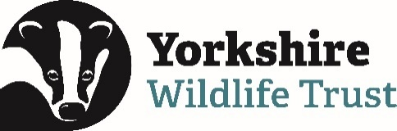 Volunteer Opportunity

Volunteer Opportunity Title
Volunteer Breeding Bird Surveyor
Reserve, Project, Team or Area
Yorkshire Wide Role (various locations), Data & Evidence Team within the Nature Recovery Directorate.
Volunteer Manager
Bethany Clarkson, Evidence Officer – With ongoing support from a Breeding Bird Survey Coordinator Volunteer.
Why do we need you?
Are you a keen birder who could put their skills to use and contribute to Yorkshire Wildlife Trust monitoring? Do you love early mornings, gorgeous sunrises, and exceptional wildlife sightings? If you love birds, getting out into nature and exploring, then you will be perfect for the Volunteer Breeding Bird surveying (BBS) opportunity!

We are currently looking to recruit Breeding Bird Volunteer Surveyors across some of our Yorkshire Wildlife Trust Reserves across Yorkshire.

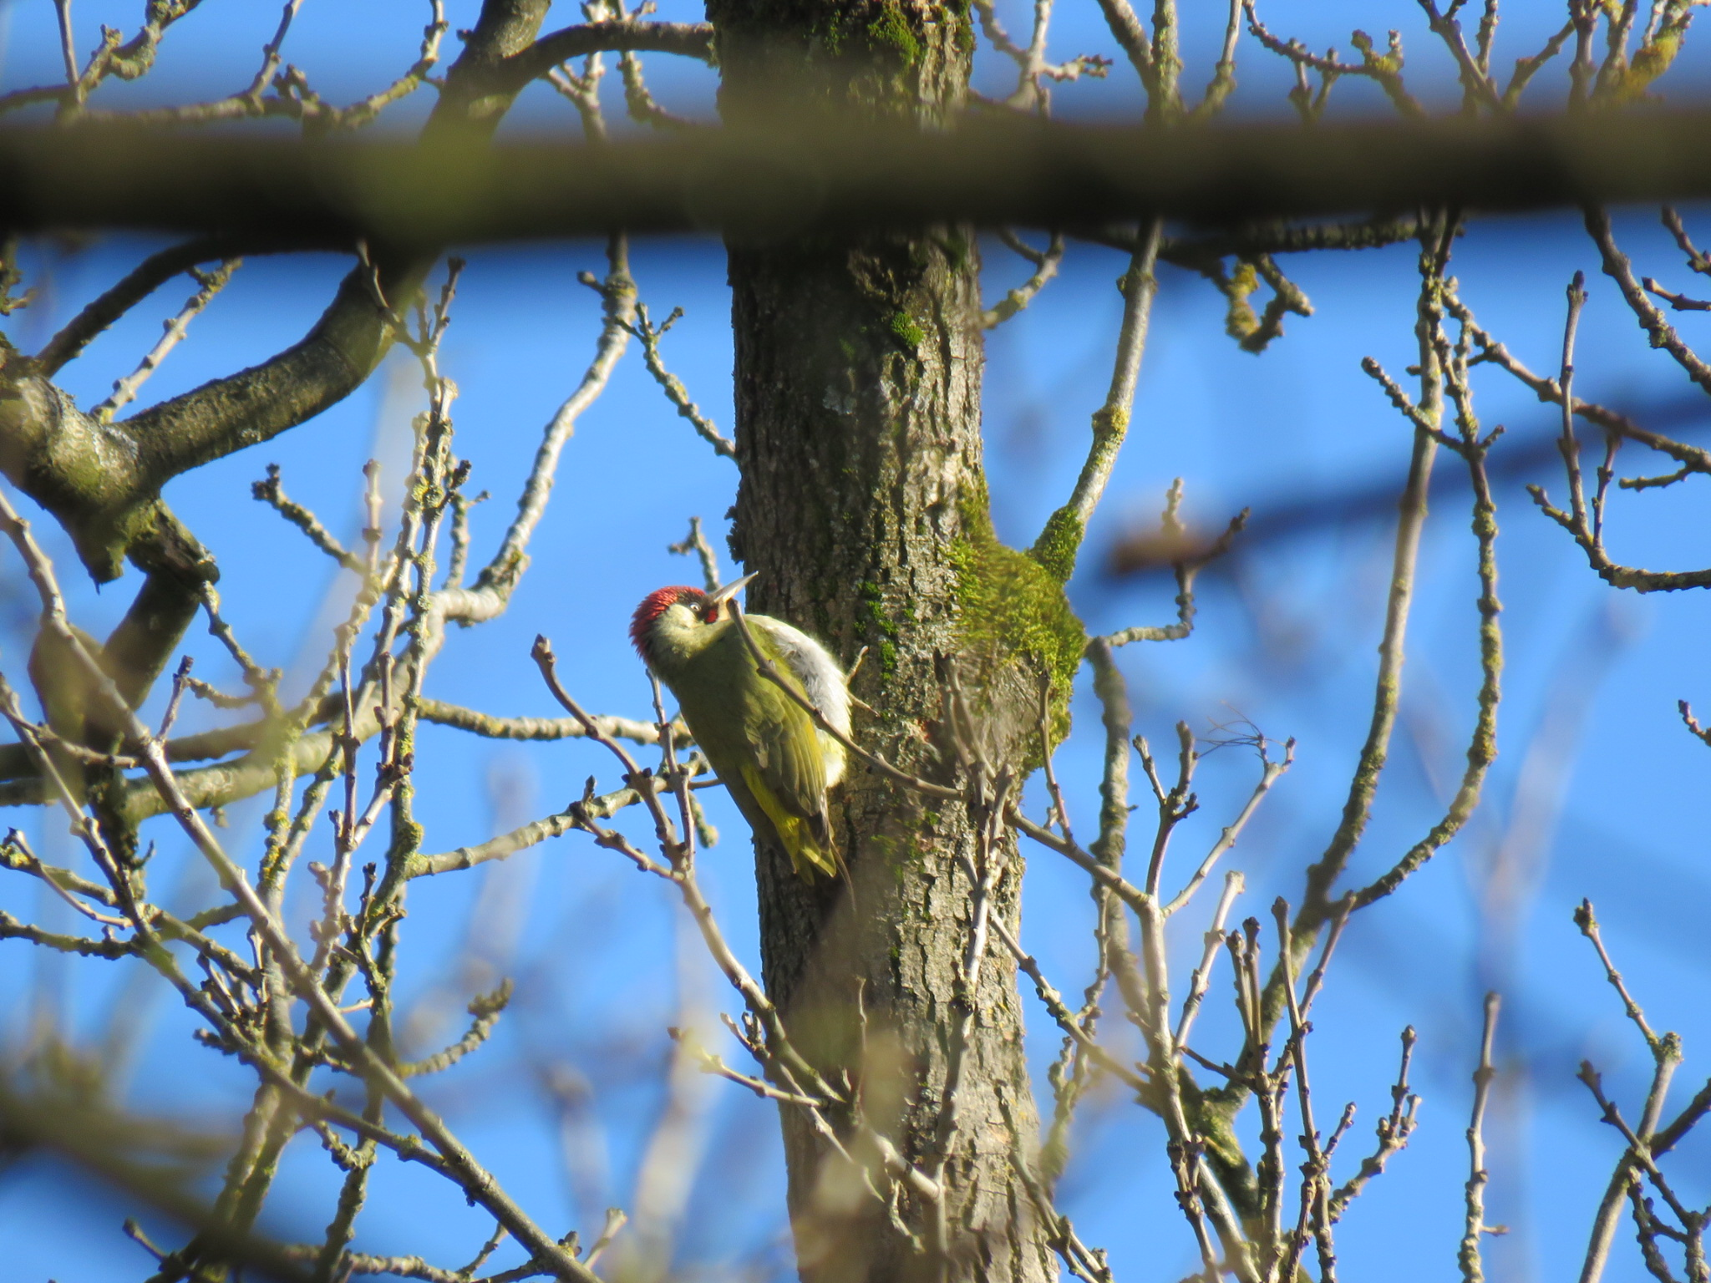

A Green Woodpecker Picus Viridis, just one bird you might see (or hear!) when conducting Breeding Bird Surveys. (Photo Credit: Becky Austin)

Breeding Bird Surveyors monitor the status and trends of bird populations. The data collected helps us create maps of bird populations in particular areas but more importantly for Yorkshire Wildlife Trust it will help to inform the work that we may or may not do on our nature reserves.

Data collected can show whether a particular bird species is in decline, and that could help us understand how we need to manage our reserves to halt that decline, and ultimately reverse it. It may lead to habitat creation, or changes in management practice that will hopefully benefit that species. It could also be that we find out a species is thriving, prompting more research into why that might be.

If you are able to identify birds by call, song and by sight throughout spring and summer, we would love to hear from you. This is a great way to learn new skills, get some exercise and be out in the fresh air.

What will you be doing?
You will be assisting with Breeding Bird Surveys on Yorkshire Wildlife Trust reserves, maintaining accurate records of breeding birds on our reserves to inform future management decisions. You will do this by being involved with the following tasks and training days:

- Undertaking bird surveys, usually 6 visits between April and July. Each survey will take around 2 hours on average, depending on the size of the site and the number of birds you hear.

- Mapping the behaviours, songs and calls you hear and see using the BTO (British Trust for Ornithology) codes provided.

- This volunteer role involves visiting our reserves often on your own. Full risk assessments and lone volunteering procedures will be shared as part of your induction.

- Reporting results back to the Breeding Bird Coordinator Volunteer.

- There will be an option to attend a Breeding Bird Survey training session prior to the start of the main survey season. This will be held in March at our Barlow Common Nature Reserve in East Yorkshire.
Experience, knowledge and skills needed for this opportunity
- The ability to read and annotate maps.

- You’ll need some Bird ID skills (both by sight and call), though there is also scope for people to team up with a more experienced birder and learn on the go.

- Must be reliable and a good timekeeper.

- Willing to be on site in the early mornings for surveys. The ideal time of day to count birds in the breeding season is roughly one hour after sunrise until mid-morning (10-11am). This generally means starting your survey no later than 9am.
Does the volunteer need a driver’s licence?
A driving licence would be ideal as some of our reserves are in remote locations, however this is not needed if you live locally to a reserve and can travel there by walking, public transport, or by cycling.
What’s in it for you?
- Training- In March we run a dedicated training day, and as a Yorkshire Wildlife Trust volunteer you will have access to a whole host of other free volunteer training and opportunities which you are able to attend.

- Meet new people- We run an annual get together of volunteers, which you will be invited to attend.

- Get outside- Get to know new places and experience Yorkshire Wildlife Trust nature reserves throughout the Spring/Summer seasons.

- Exercise- you’ll be walking a fair bit with this role and where better than out in the nature!

- Be part of something- You’ll be involved in gathering important breeding bird records, which will allow us to monitor trends and see the impact of and guide our management of our nature reserves.
- 15% discount in Yorkshire Wildlife Trust shop and 15% discount at cafes when volunteering

Where is the opportunity based?
Breeding Bird Surveys are conducted across our reserves. You can see a list of many of our nature reserves here: YWT Nature Reserves

We are currently carrying out recruitment for potential surveyors across Yorkshire and as a result we’re not able to specify which reserves will need to be surveyed in Summer 2025, however we expect to be able to share the locations we’ll need to survey by early spring 2025.

Commitment
Up to 6 surveys annually.
Duration
Between April to July 2025.
If you are interested in applying for this volunteer role, please send in a completed volunteer application form to volunteering@ywt.org.uk by Friday 21st March 2025.

