
Volunteer Role Description

Volunteer Role Title | Role Number
Volunteer Livestock Checker – Stirley, near Huddersfield
Reserve, Project, Team or Area
Stirley, Reserves Team West

Volunteer Manager/Supervisor
Mary Painter, Reserves Officer - West
Why do we need this volunteer?
Do you fancy keeping fit whilst getting some fresh air? Would you like to help us check Livestock in particular our ‘udderley’ brilliant Cattle or baaa-rilliant sheep to make sure they’re in good health?

You might be wondering why we have Livestock at our nature reserves! Yorkshire Wildlife Trust manages over 100 reserves, restoring biodiversity, protecting habitats and wildlife and providing wonderful opportunities for visitors to get close up and see some of our most enthralling wildlife. Part of the management of many of our grassland, fen and heathland reserves is carried out by grazing animals. Grazing helps control competitive ‘rough’ plant species that can out-compete the finer, more interesting species of grass and wildflower that we seek to encourage. Livestock on the reserves need to be checked to ensure that their health is good, and that they are still all there.
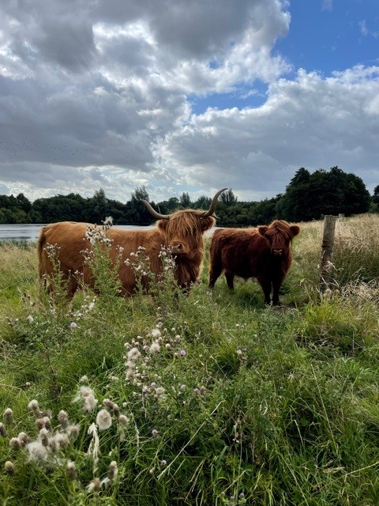
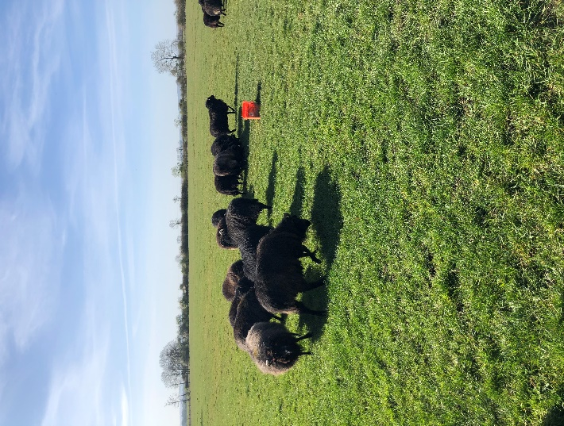

Can you help us check our amazing grazers?
Photo Credit: Charlotte Dring

What will the volunteer be doing?
- Each visit involves a walk across the area being grazed, counting the number of animals and looking for any signs of ill health. If you did see any problems, you would not be expected to deal with them, simply to ring us at YWT to let us know.
- Each visit will take approximately 1 – 1.5 hours depending on where the livestock are on site.
- We usually work a rota system, so a group of people take it in turns to check stock at a certain site, so each individual’s commitment is not too great. We’re currently looking for someone who can carry out a check on Sundays, preferably in the morning as this gives the team chance to respond to any problems during daylight hours.
- An introduction to the site will be given, with a site and task risk assessment, plus information on what to look out for, more common problems encountered, tell-tale signs of illness etc. This will be given in person on site and/or followed up by a written reminder document.
Experience, knowledge and skills needed for this role
- No previous knowledge or experience necessary, but you need to feel confident being around grazing animals, and any past experience or knowledge of stock welcome.
- Reliability – the volunteer must check the stock on their allocated day, or let us know if they can’t so we can make other arrangements. We have a Whatsapp group which people use to swap days when needed.
- You also need to be fairly physically fit as some of the grazing areas have rough terrain, tussocks, boggy ground etc. that you need to be able to negotiate.

Does the volunteer need a driver’s license? Yes – unless you live within walking distance of the reserve.

**Any tasks involving sheep and lambing can be harmful to pregnant women, so please bear this in mind when applying for this volunteer role. **
What’s in it for you?
- The chance to visit one of YWT’s superb reserves throughout a season, seeing it develop and change, and enjoying the wildlife it supports.
- The chance to get to work with our grazing stock – cattle and sometimes sheep. Each have their own personalities and are a joy to get to know.
- Learn skills in animal welfare and care.
- Learn some more about nature reserve management
- Spending the day with our lovely livestock!
Where is the role based?
Stirley, off Hall Bower Lane, Huddersfield, HD4 6FA
Commitment
Each checking visit may take between an hour to an hour and a half, depending on the task.
We are currently looking for a person to help on Sundays only
Duration
ongoing (throughout the year)
To apply for this role please complete a volunteer application for and email it to volunteering@ywt.org.uk

