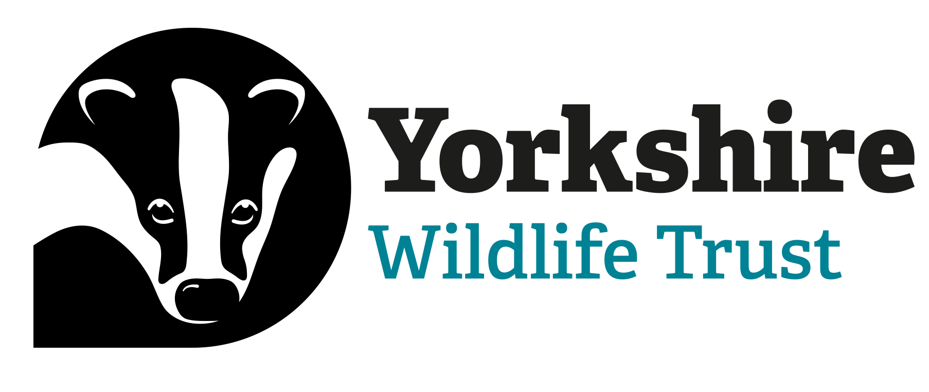

Voluntary Role Title | Location
Spurn Residential Volunteer | Spurn NNR East Yorkshire
Supervisor
Clare Galpin, Reserves Assistant - Spurn
Reserve/Project/Team/Area
Spurn National Nature Reserve
Background
Spurn is a coastal spit that stretches 3.5 miles between the North Sea and the Humber estuary, close to the Holderness Inshore marine protected area. Spurn has a beautiful and varied landscape alongside a rich military and maritime history. These combined are a huge draw for visitors throughout the year.

Yorkshire Wildlife Trust is making a significant investment in Spurn to transform it into one of Britain’s finest nature reserves. There are several new and developing projects at Spurn such the beach nesting bird project and seagrass and oyster restoration works on the Humber estuary. Not only do these exciting projects increase biodiversity and improve habitats, but they also increase the value of the area and make a positive contribution to the local economy through nature tourism.

Previous Spurn residential volunteers have gained employment within the conservation sector doing various roles, such as ecology assistants, consultants, or with Yorkshire Wildlife Trust. A previous residential volunteer, says, “Spurn is a phenomenal place to spend time volunteering and living. I really became involved in all the activities that went on at Spurn. The best part was that I was able to tailor my experience to suit my interests and I discovered my strengths and which areas of conservation I enjoyed the most. The whole experience really helped me to take the next steps in my career”.

Role
We are looking for a volunteer with enthusiasm for conservation and the natural environment to join the Spurn team from June to September. This is an amazing opportunity to be part of the exciting developments at Spurn National Nature Reserve, helping to make it an exceptional place to visit. As Spurn is remote, we offer on-site accommodation with utility bills paid.

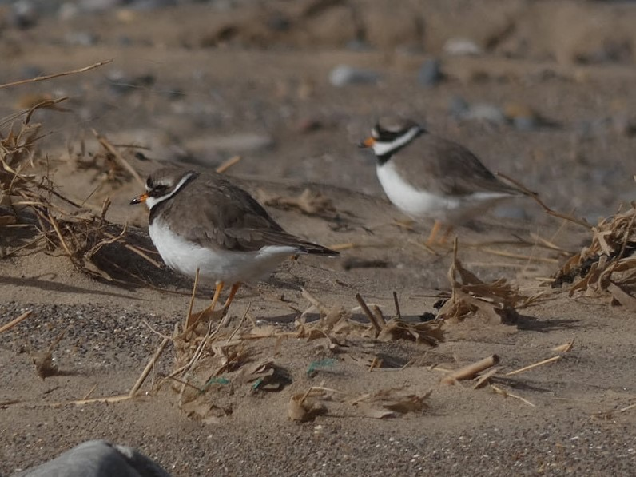
The variety of tasks you will be able to take part in during your time at Spurn will provide a good mix of skills for those who want to build a future career in conservation.

You will receive training in surveying and assist with the surveying schedule. You will also take part in reserve management to maintain the reserve, learn about conservation grazing, and how to work with livestock. You will also be part of the public’s visitor experience by welcoming visitors on-site and providing important information.

What you’ll be doing
You will be involved in a broad range of tasks and activities at Spurn NNR. The focus will be on:
- Beach nesting bird project assistance
- Assisting in ecological surveys and using GIS to map flora and fauna
- Habitat management
- Take part in regular practical task days

You could also be involved in:
- Supporting education events/workshops and public engagement activities
- Promoting visitor engagement- such as membership and visitor admissions
- Acting as a friendly point of call for visitors and help with essential health and safety information relating to the site
- Assisting with livestock checks

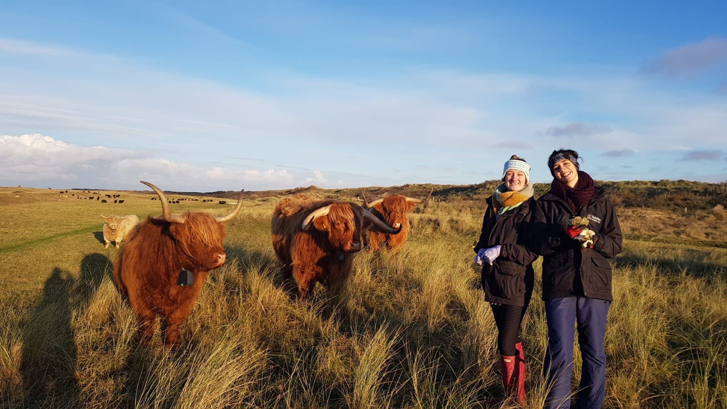

Highland Cattle at Spurn Point - YWT

What we can offer you
You will have the opportunity to live on-site and completely immerse yourself in Spurn’s unique environment.
On a quiet evening, you can scan the Humber for flocks of waders, the East Coast is well known for attracting its migrating rarities. Alternatively, you can stroll along the beach looking for sea glass and fossils that the tide has brought in. It’s an incredible and isolated place, in which you become completely immersed while gaining vital experience in the conservation sector.

You will be an important part of the team and will receive support and encouragement throughout your time here.

Main areas of experience you will gain:
- Practical experience in ecological surveys and research
- Practical hands-on experience in land management for nature conservation (Electric fence maintenance, livestock handling, scrub clearance, etc.)
- Training and qualifications in conservation management (e.g. Relevant equipment/ 4x4 vehicle /species ID, survey skills)

Additionally, you could also gain:
- Experience in running events and workshops for the public
- Experience of working within a busy customer-facing environment

You can expect:
- Access to our internal volunteer training programme
- Training will be provided for Species ID and survey methods
- Ongoing personal and career development training and one-to-one support from your line manager and the volunteering team
- An intensive and high-quality experience that will stand out on any CV, as a team member of one of the UK’s most vibrant and respected conservation organisations
- 15% discount in Yorkshire Wildlife Trust shops. 15% discount at Yorkshire Wildlife Trust cafes when you are volunteering.

Accommodation:
We provide accommodation during the volunteer placement within walking distance of site, which is shared with other residential volunteers. This is a static caravan, consisting of 3 bedrooms, a shower and toilet facility, a kitchen, and living area with all bills paid.

As part of the interview process, you can visit the accommodation and get a feel for the place to decide if you would be happy living on-site.

Parking is provided but borrowing bikes from the Discovery Centre or bringing your own is also possible.

Experience, knowledge and skills needed for this role
You will need:
- An enthusiastic, friendly, and approachable nature
- Good understanding of ecology/conservation/land management
- Good communication skills
- Ability to work in a team
- Enthusiasm and willingness to learn
- The ability to live in close quarters with other volunteers
- Self-motivated and happy to work in a relatively isolated place
- A desire to inspire and empower people to take action for wildlife
- Computer literate in Word and Excel (GIS experience is desirable)

Does the Trainee need a driver’s license? Yes, as this is a remote area with very limited public transport.
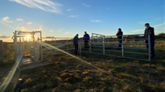

Working with Livestock at Spurn Point - YWT
Commitment
3 days a week is the minimum commitment, but volunteers are welcome to undertake extra days if it is beneficial to their experience and is agreed with their line manager.

Duration
4 months

