

Voluntary Trainee Role Title | Location
Nature Reserves Voluntary Trainee - East | Vale of York and East Yorkshire
Supervisor
Dave Powell – Living Landscapes Officer
Reserve/Project/Team/Area
Vale of York - East Region
Background
Our East Reserves Team working across the Vale of York and into East Yorkshire are looking for a passionate individual to join the team as a voluntary trainee to support staff to undertake practical land management tasks, support with the delivery of volunteer task days and learn reserve administrative management.

You will help with the management of some of our most beautiful nature reserves giving you a broad range of practical and administrative skills across different habitats and further protecting Yorkshire’s wildlife. From our first nature reserve Askham Bog with its mosaic of fen, woodland and meadow, to the York lowland heaths, you’ll be working with a broad range of habitats and associated fauna and flora in this varied role.

This role will involve a variety of outdoor practical conservation tasks on nature reserves as well as office-based tasks, which will give you the essential background knowledge and understanding to enhance the practical side of the role.

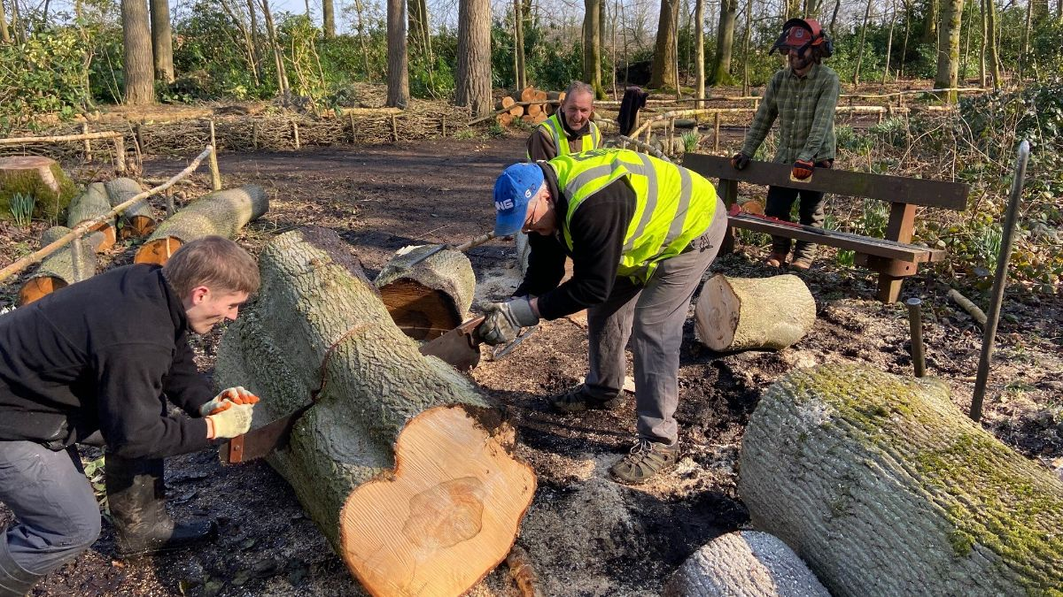
Former Nature Reserves Voluntary Trainee carrying out felling tasks © YWT
What will you be doing?
Practical reserve tasks will include:
- Carrying out habitat management activities such as scrub clearance, brushcutting, invasive plant control, livestock management, fence and gate repairs and rubbish removal amongst a variety of other tasks.
- Days will often involve working with local volunteers to manage sites and part of the role will eventually include leading volunteer groups in practical activities.
- Due to the physical nature of these tasks, the role does require a reasonable level of physical fitness and willingness to work outdoors year-round in all weathers.

Office based tasks will include some of the following:
- Fielding enquiries, as well as other reserves administration.
- There may also be opportunities to be involved in leading and organising events, helping with educational activities and working with other teams across Yorkshire Wildlife Trust according to the interests of the trainee.

What’s in it for you?
There is the opportunity to learn a wide variety of skills and to expand your knowledge with our varied internal volunteer training programme, along with a generous training budget for external training.

You will gain experience in:
- Practical land management e.g. grassland management, scrub removal, tree felling.
- Invasive species removal.
- Fencing and other essential maintenance work on reserves.
- Livestock checking and assisting with livestock movements.
- Assisting with the delivery of volunteer task days.
- Writing risk assessments for practical tasks.
- Learning about reserve management planning and CMSi software to create management plans.
- Knowledge about grazing agreements.
- Assisting with the planning and delivery of events.

You can expect:
- Reasonable travel expenses (up to £16.20 per day of your traineeship, capped at £195 per month.
- £600 training budget which will include certificates in first aid and specific land management skills (brushcutter) with the remaining budget being spent on external training for your own personal development.
- Ongoing personal and career development training and one-to-one support from your line manager and the Volunteering Team staff
- An intensive and high quality experience that will stand out on any CV, as a team member of one of the UK’s most vibrant and varied conservation organisations
Experience, knowledge and skills needed for this role
You will need:
Essential;
- Enthusiasm for and understanding of the basic principles of nature conservation.
- Willingness and ability to learn new practical skills and undertake physically demanding tasks.
- Ability to work outdoors, in all weather conditions for extended periods of time, sometimes in remote locations.
- Ability to communicate effectively and willingness to talk to groups.
- Working knowledge of Microsoft Office software particularly Word, Excel, Outlook and Teams.
- Driving Licence
Desirable;
- Experience of undertaking practical tasks.
- Knowledge of wildlife and natural history

Does the Trainee need a driver’s license? Yes - Most of our work sites are located in remote locations, away from main public transport routes, therefore this role is more suited to a person who holds a full driving license and is willing to drive as part of the role. You will be able to access a company vehicle during normal working hours subject to other staff needs.
Commitment
3 days a week between Monday – Friday. This can be flexible and to be discussed with candidates
Duration
12 months starting in Late May/June 2024
Does this role involve working with children or vulnerable adults?
Yes- The trainee may deliver occasional family events.
Will the role involve any other sensitive tasks for which we may wish to check suitability via a criminal records check?
All Trainees will be asked for two references
Risk assessment complete? Yes
Relevant Factors:
- Undertaking practical tasks e.g. removal of invasive plant species, tree felling, cutting/raking grassland, and scrub clearance.
- Working in all weathers for prolonged periods of time.
- Working in isolated places.
- Good level of fitness required as some tasks will be more demanding than others.
- Use of tools, equipment and materials relevant to practical tasks e.g. bow saw, loppers.
- Use of hazardous substances e.g. pesticides.

First Aid Training? Yes- First Aid at Work required as part of role and can be organised for the successful candidate.
Other Desirable: Brushcutter training provided through the post and one other
Closing date for applications: Tuesday 14th May 2024
Interviews: Week commencing 27th May 2024 in the York Office
Applications details can be found here: https://www.ywt.org.uk/voluntary-traineeships
Please send all completed application forms to volunteering@ywt.org.uk

